Advanced Persistent Threat (APT) Simulation using Splunk & Sysmon

INDEX
1. | Abstract
2. | Introduction
3. | Objective
4. | System Architecture
5. | Implementation
6. | Attack Simulation
7. | Detection Techniques
8. | Dashboards
9. | Results
10. | Challenges
11. | Conclusions
12. | Reference
Title Page

Project Title: Advanced Persistent Threat (APT) Simulation using Splunk & Sysmon
Name:- Om Santosh Mane
Course:- Cybersecurity

Abstract

This project focuses on simulating Advanced Persistent Threat (APT) attacks and detecting them using a Security Information and Event Management (SIEM) system. A lab environment was created using Splunk, Sysmon, and Windows to monitor system activity and analyze logs. Various attack techniques such as PowerShell execution, encoded commands, persistence through registry keys, and network communication were simulated. These activities were captured and analyzed using Splunk, where detection rules and alerts were created. The project demonstrates how real-world cyber attacks can be detected using log analysis and monitoring tools, providing practical knowledge of cybersecurity operations.

2. Introduction

Cybersecurity is the practice of protecting systems, networks, and data from digital attacks. With the increasing number of cyber threats, organizations require advanced monitoring systems to detect malicious activities.
An Advanced Persistent Threat (APT) is a type of cyber attack where an attacker gains unauthorized access to a system and remains undetected for a long period. These attacks are complex and involve multiple stages such as execution, persistence, and communication.
To detect such threats, organizations use SIEM tools like Splunk, which collect and analyze logs from different systems. This project aims to simulate APT behavior and detect it using Splunk and Sysmon, providing hands-on experience in real-world cybersecurity scenarios.

3.Objectives

- To build a SIEM-based monitoring system using Splunk
- To simulate attacker behavior in a controlled lab environment
- To detect suspicious activities using system logs
- To understand real-world cyber attack techniques
- To design a simulation framework that emulates the behavior of APT actors using open-source offensive security tools.
- To create a secure environment for performing and analyzing multi-stage attacks.
- To generate detection rules and threat intelligence indicators for defensive teams.
- To demonstrate end-to-end attack detection, logging, and mitigation within a lab setup.

4.System Architecture
The architecture of the system is as follows:
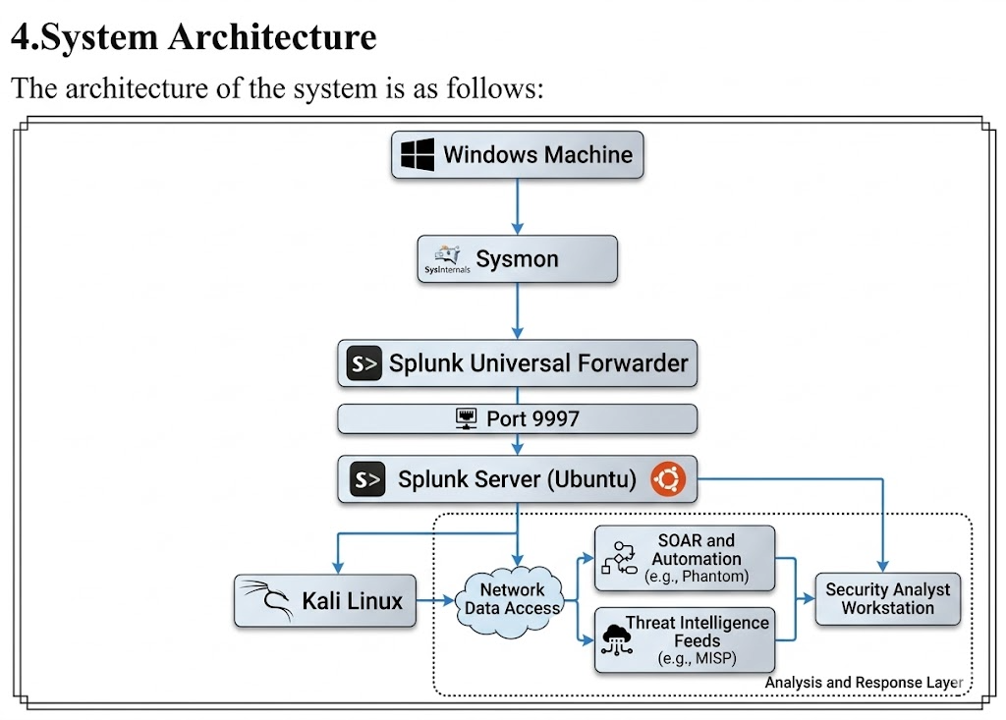
- Windows machine generates logs
- Sysmon captures detailed system activity
- Universal Forwarder sends logs to Splunk
- Splunk Server analyzes and visualizes logs

5.Tools and Technologies Used

Splunk Enterprise
Used as a SIEM tool to collect, analyze, and visualize logs.

Sysmon
A Windows system monitoring tool that records detailed system activity such as process creation, network connections, and registry changes.

Splunk Universal Forwarder
Used to send logs from Windows machine to Splunk server.

Windows OS
Used as the target system where activities and attacks are simulated.

Ubuntu Server
Used to host the Splunk server.

Kali Linux
Used to simulate attack scenarios such as network scanning

6.Implementation
Step 1: Setup Splunk Server
Splunk was installed on Ubuntu server and configured to receive data on port 9997.

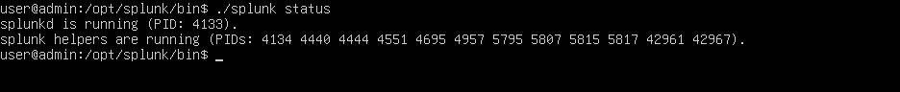
Figure 1: Splunk Services Running on Ubuntu Server

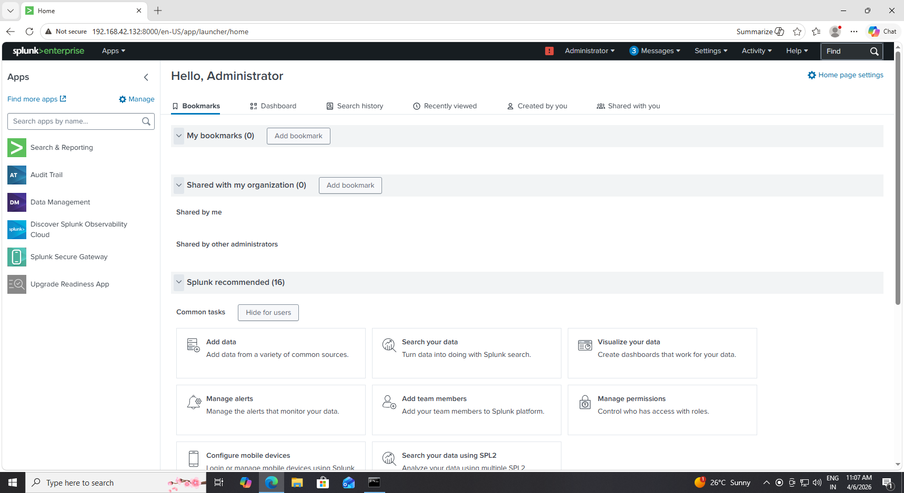
Figure 2: Splunk Web Interface Successfully Accessed
The above figure shows that the Splunk services are running successfully on the Ubuntu server.
The Web Interface Confirms That the Splunk server is accessible and ready to receive logs.
Step 2: Install Universal Forwarder
Splunk Universal Forwarder was installed on the Windows machine to send logs.

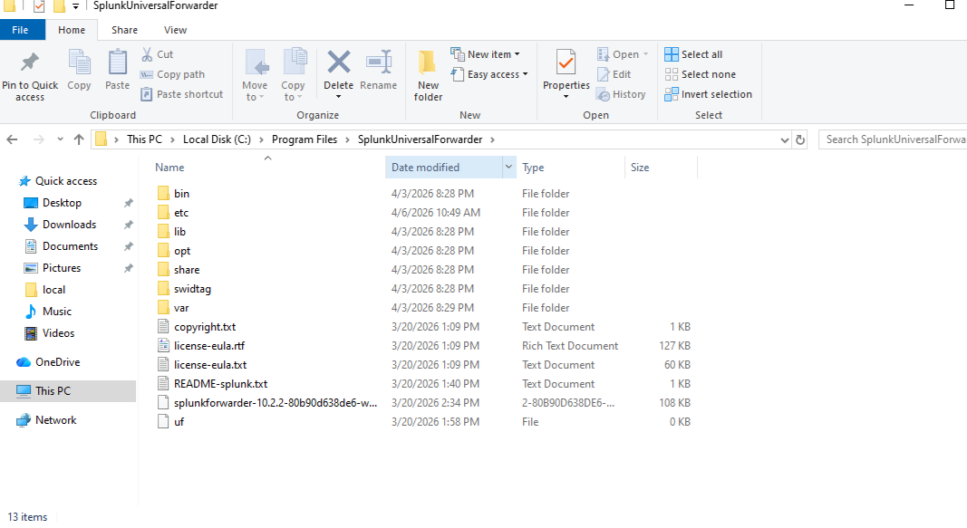
Figure 3: Splunk Universal Forwarder Installed Successfully on Windows
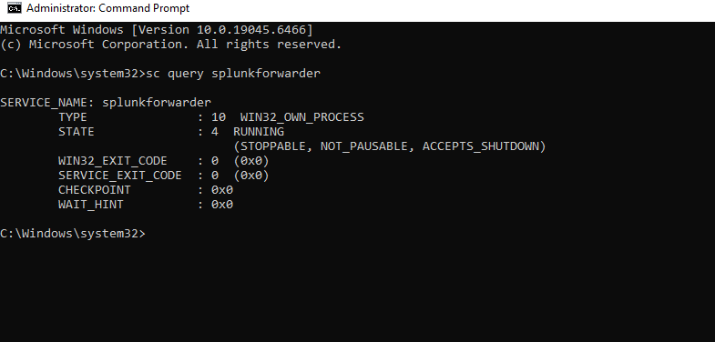
Figure 4: Splunk Universal Forwarder Service Running
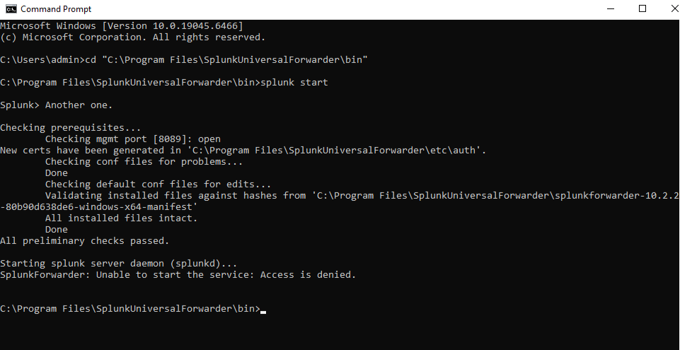
Figure 5: Starting Splunk Universal Forwarder Service

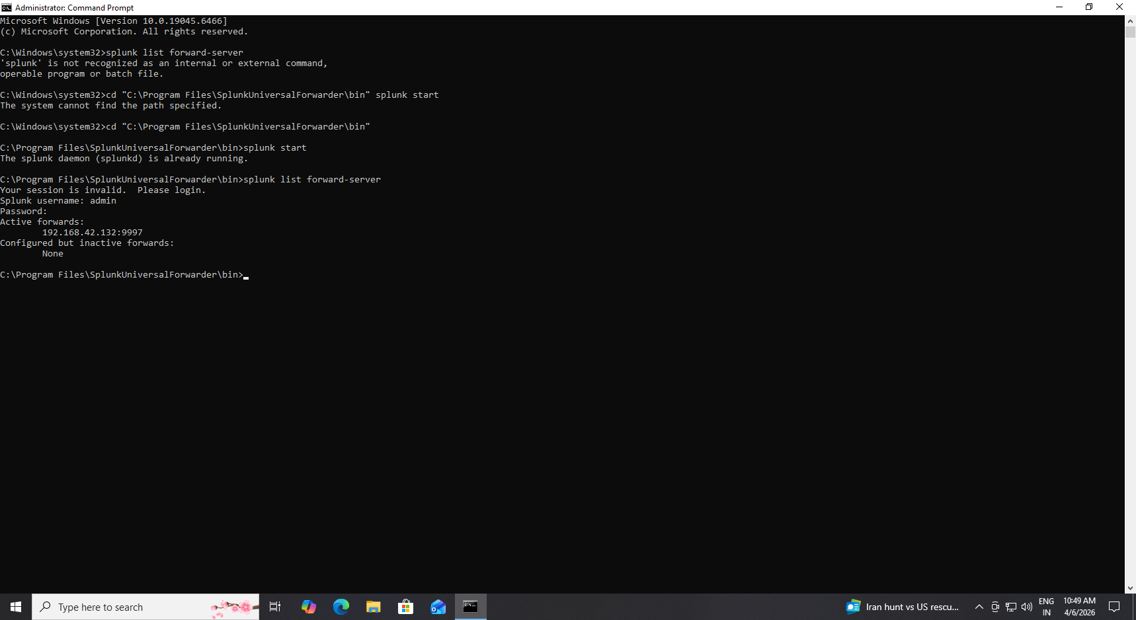
Figure 6: Splunk Universal Forwarder Successfully Connected to Splunk Server

The above figure shows that the Splunk Universal Forwarder has been successfully installed on the windows machine.
The service status confirms that the forwarder is running and ready to send logs to the Splunk server.
Step 3: Configure Sysmon
Sysmon was installed with a configuration file to enable logging of:
- Process Creation (Event ID 1)
- Network connections (Event ID 3)
- Network connections (Event ID 3)
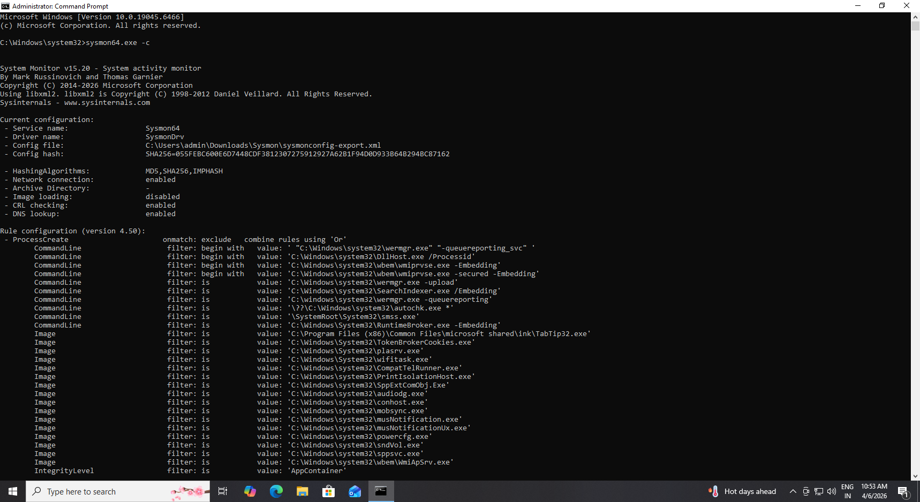
Figure 7: Sysmon Configuration Showing Enabled Logging Features
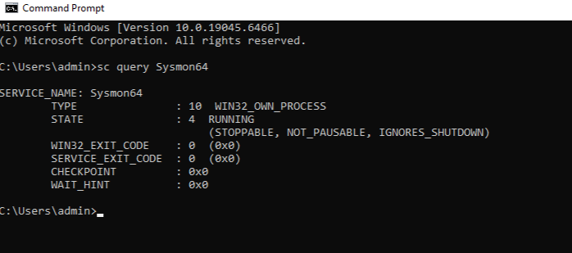
Figure 8: Sysmon Service Running on Windows System
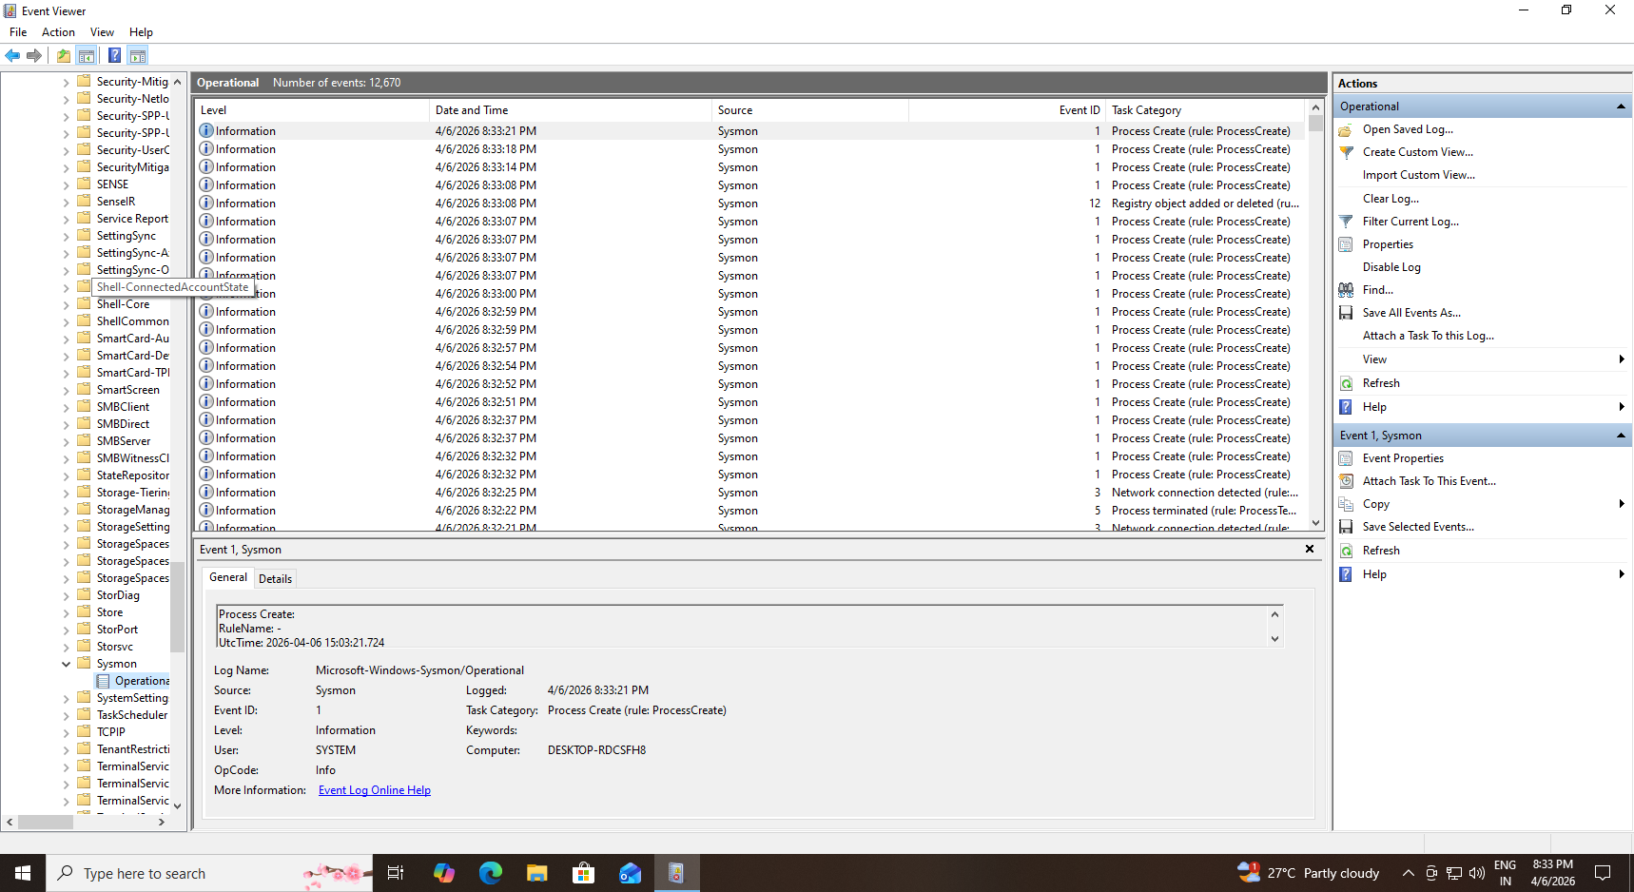
Figure 9: Sysmon logs visible in Event Viewer

The above figure shows that Sysmon has been successfully installed with the configuration file, enabling detailed system monitoring.
The configuration output confirms that network logging and other features are enabled.
The event Viewer Logs Demonstrate that Sysmon is actively recording system activity.

Step 4: Connect Forwarder to Splunk
The forwarder was configured to send logs to the Splunk server.

Figure 10: Forwarder Successfully Connected to Splunk Server

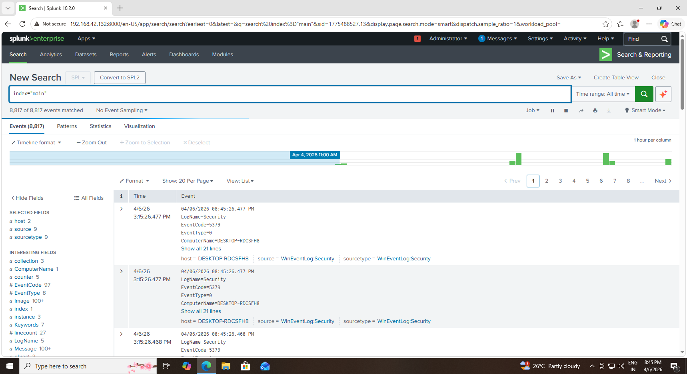
Figure 11: Logs Successfully Received in Splunk from Forwarder

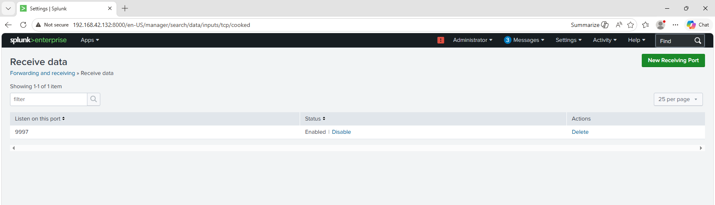
Figure 12: Splunk Server Configured to Receive Data on Port 9997
The Splunk Universal Forwarder was configured to send logs to the Splunk server using the server IP address and port 9997.
The above figure shows that the forwarder is actively connected to the Splunk server.
The logs are successfully received and displayed in Splunk, confirming proper data flow.
Step 5: Configure Log Inputs
Sysmon logs were configured in inputs.conf to be forwarded to Splunk.

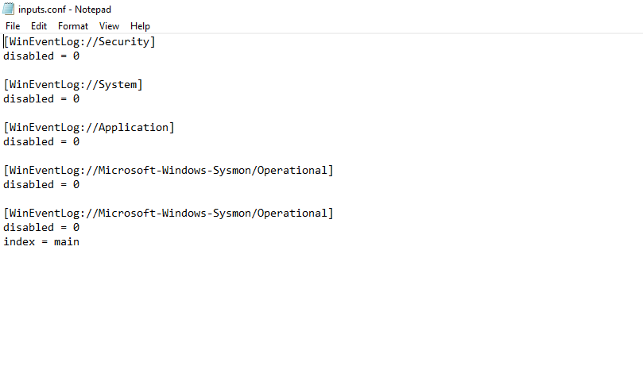
Figure 13: Configuration of Sysmon Log Inputs in Inputs.conf File

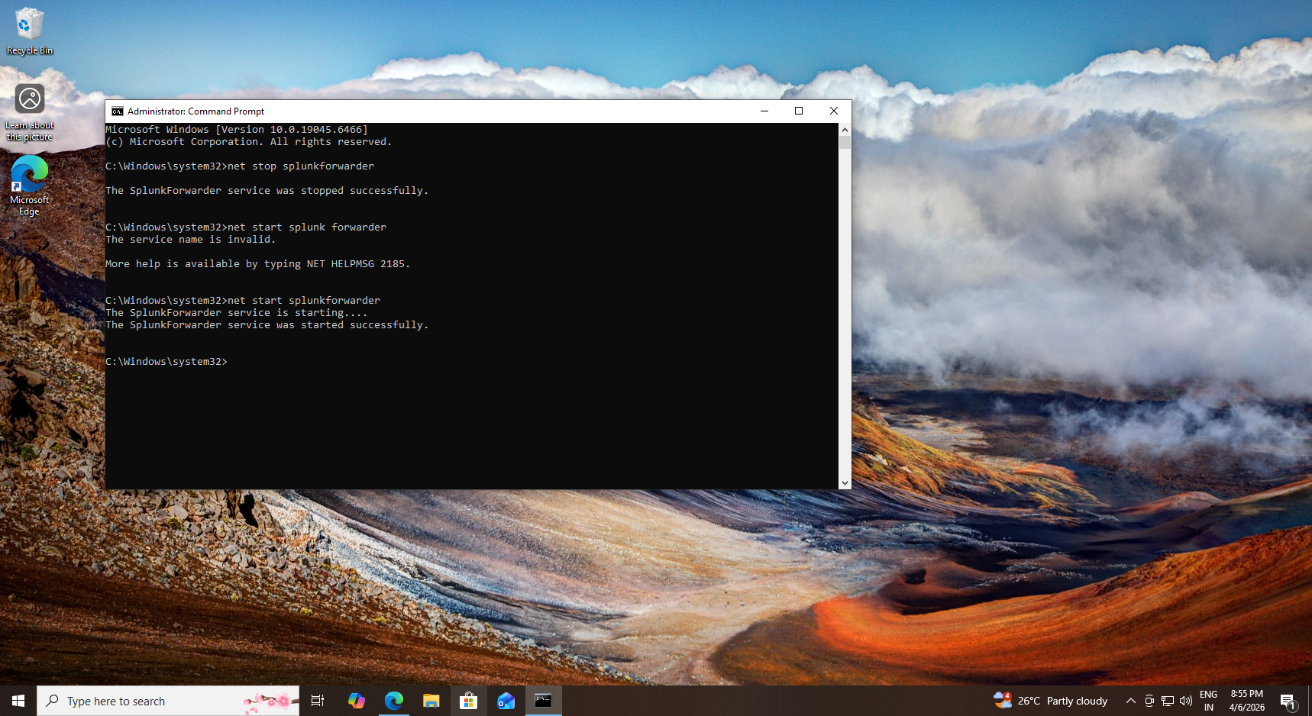
Figure 14: Restarting Splunk Universal Forwarder to Apply Log Configuration

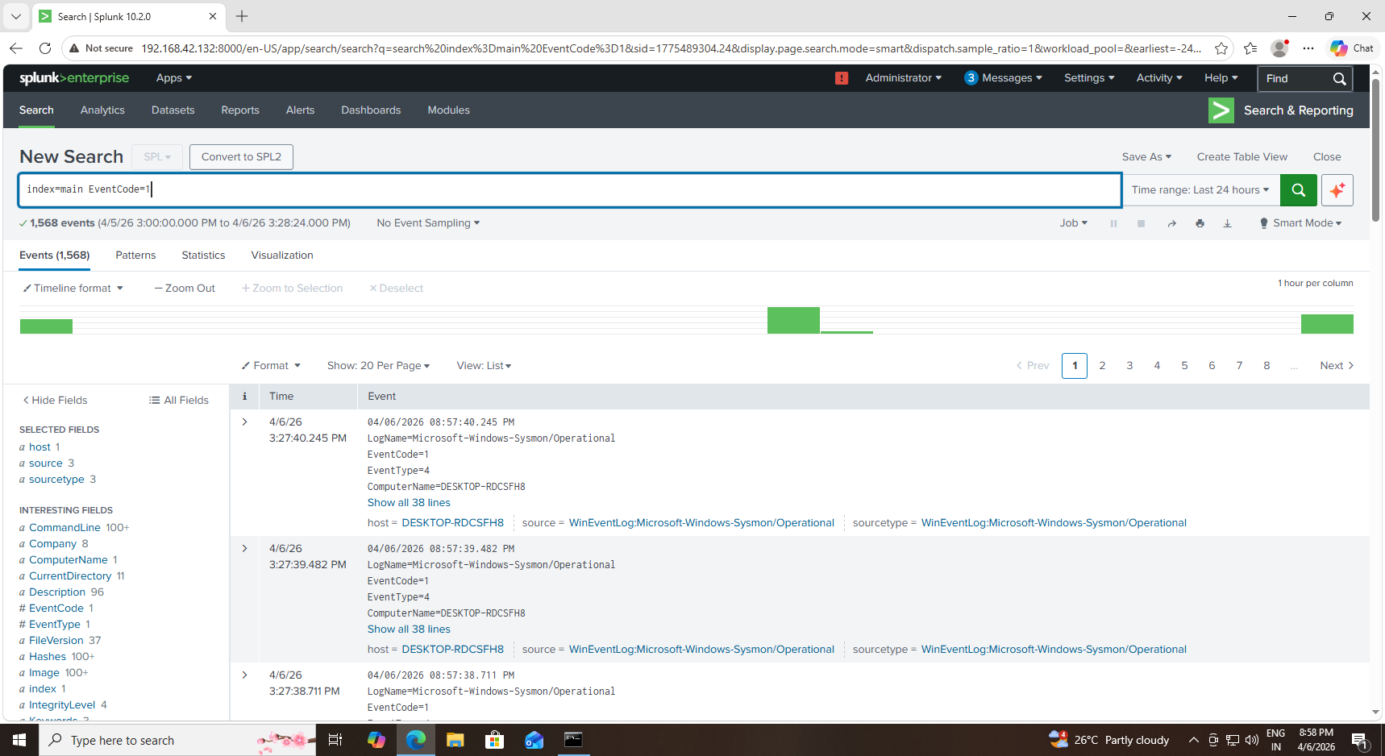
Figure 15: Sysmon Logs Successfully Collected and Visible in Splunk

The inputs.conf file was configured to collect Sysmon logs from the Windows system and forward them to the Splunk server.
The configuration ensures that Sysmon operational logs are enabled and sent to the main index.
The forwarder service was restarted to apply the new configuration settings.
The logs are successfully visible in Splunk, confirming that the input configuration is working correctly.

Step 6: Create Alerts
Alerts were created in Splunk to detect suspicious activities such as PowerShell execution.
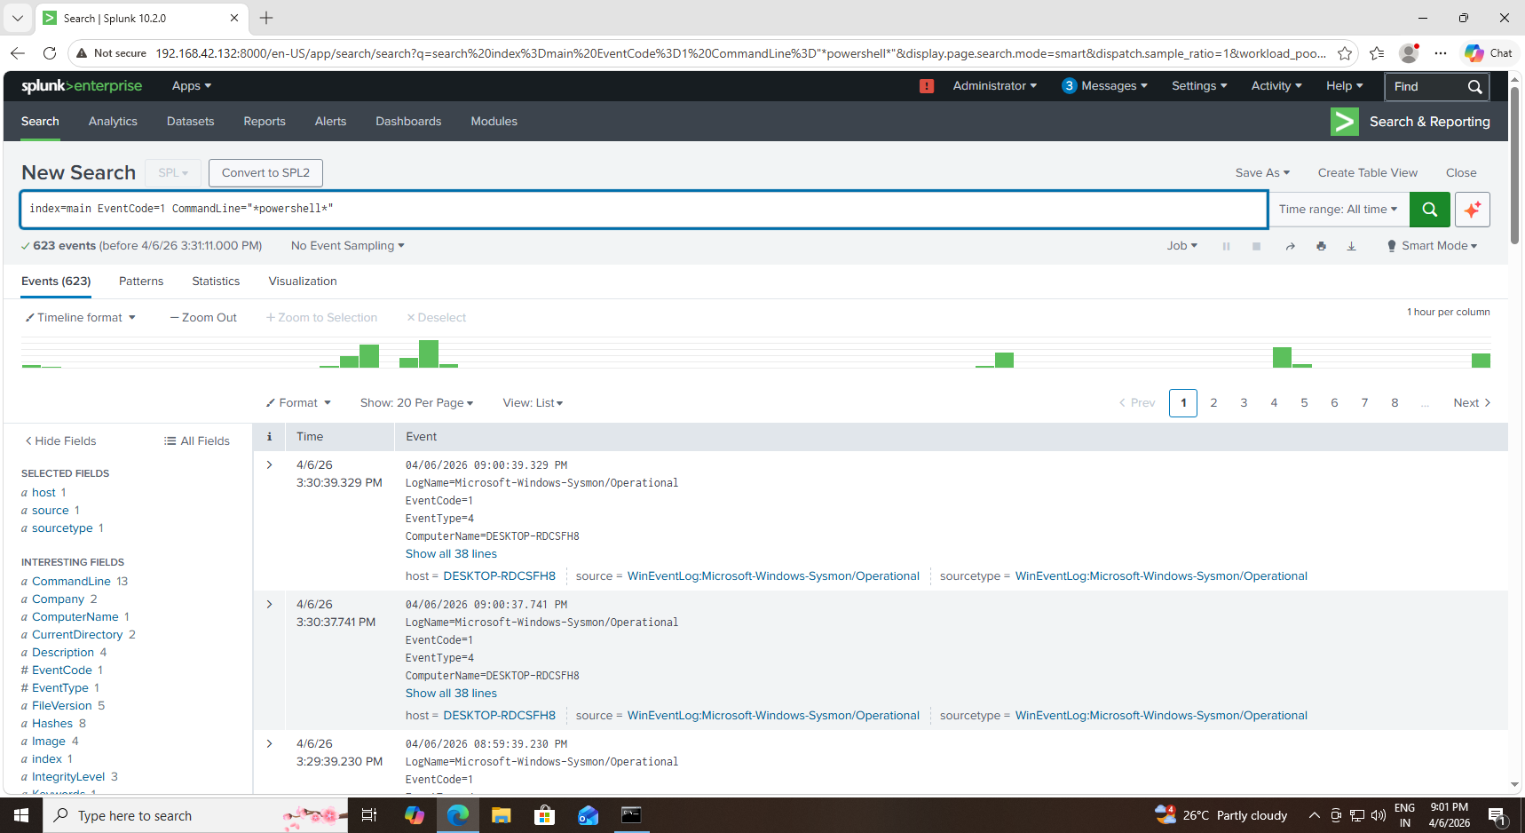
Figure 16: Detection Query for Suspicious PowerShell Execution

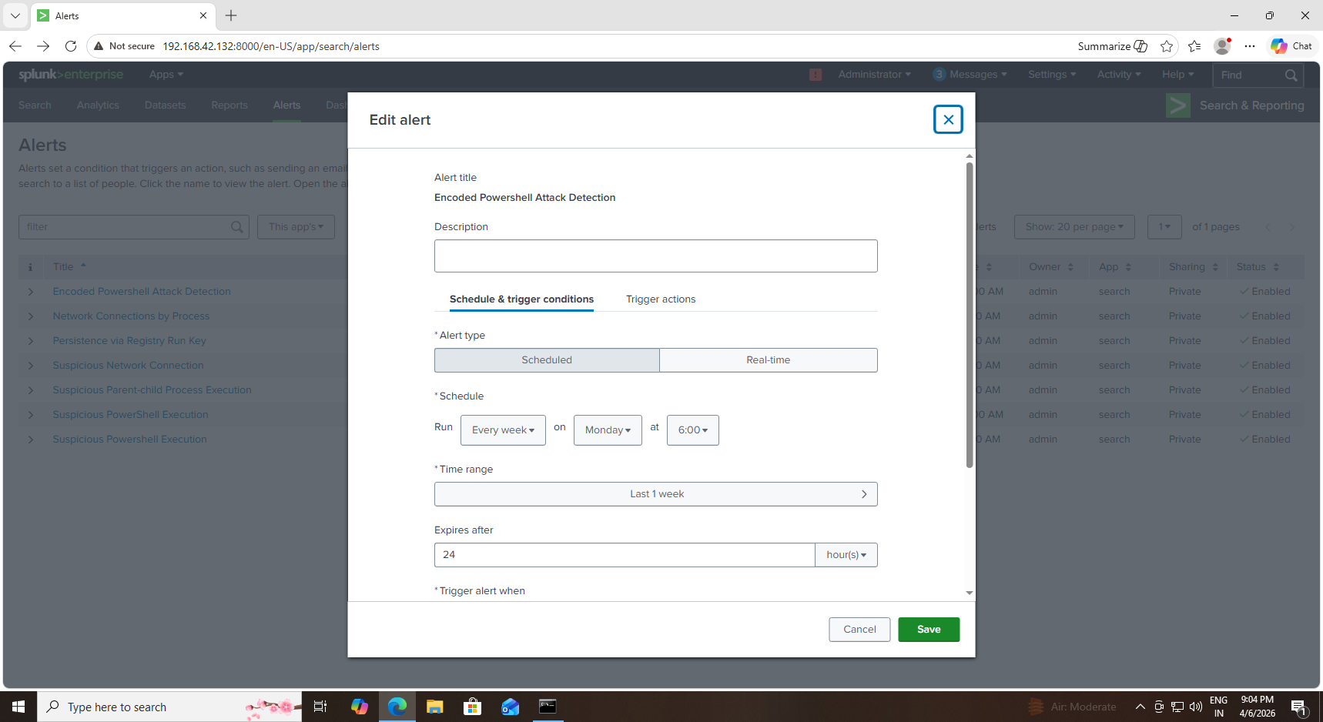
Figure 17: Configuration of Alert for Suspicious Activity Detection

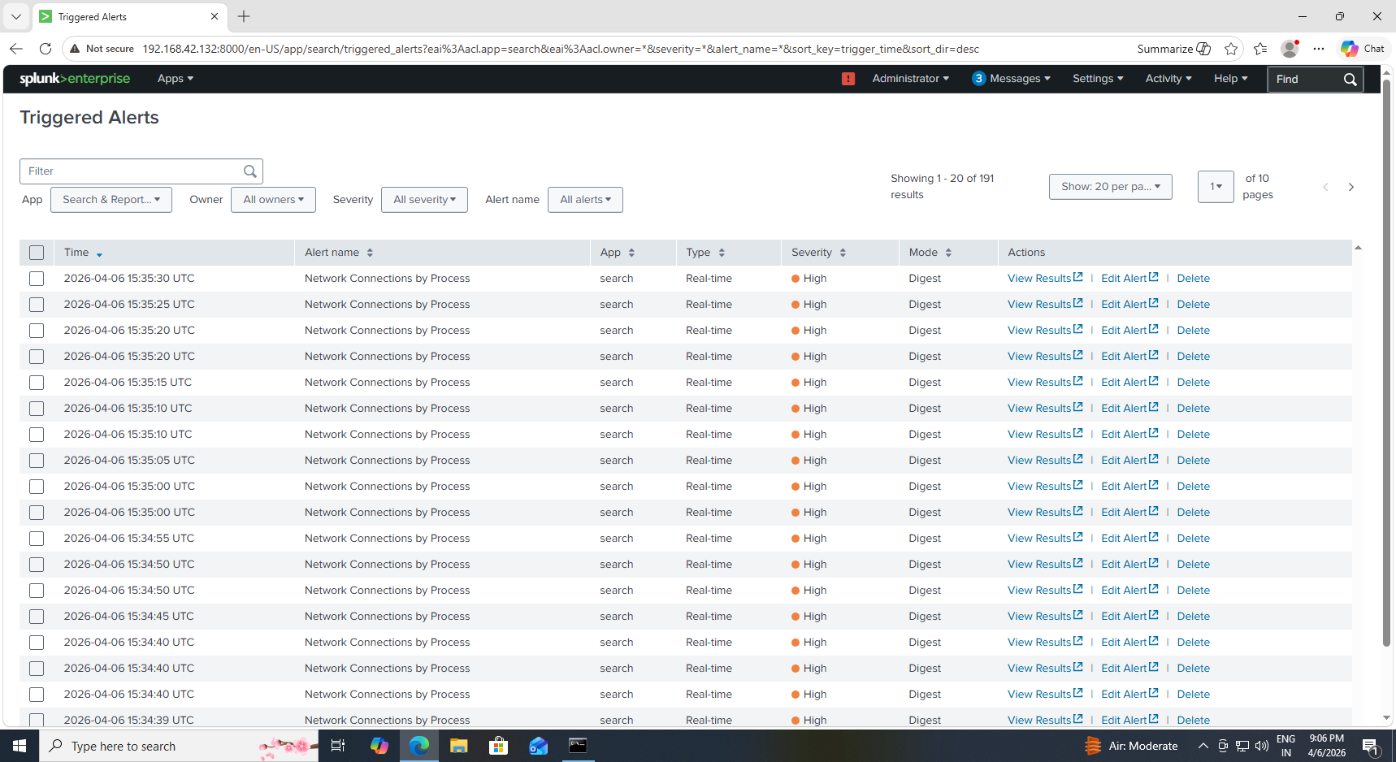
Figure 18: Alert Triggered for Suspicious PowerShell Activity

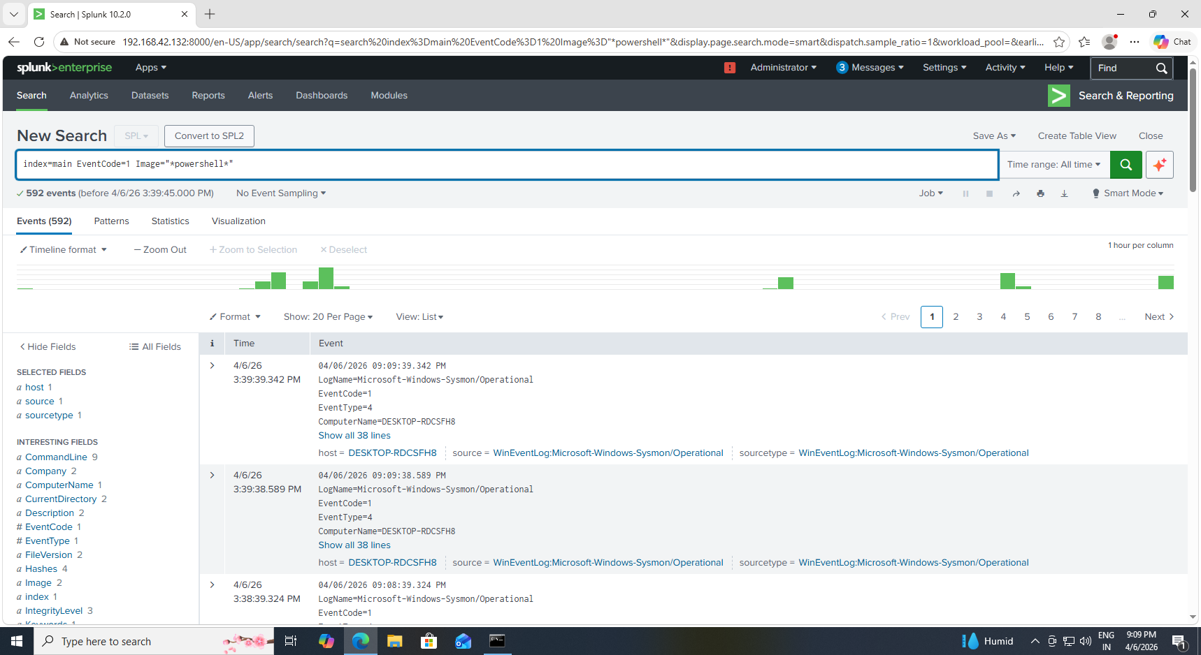
Figure 19: Dashboard Panel Showing PowerShell Execution Activity

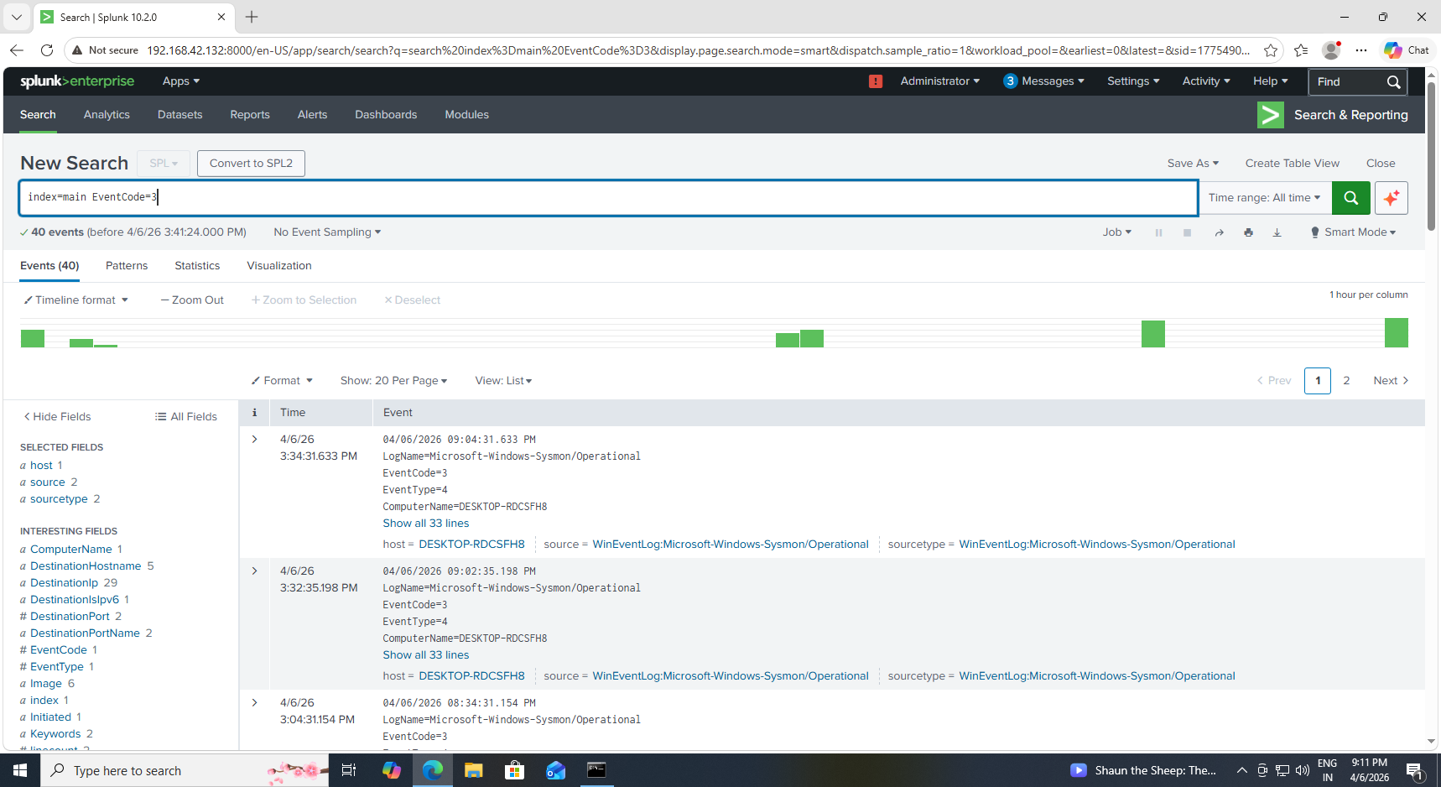
Figure 20: Dashboard Panel Showing Network Connections

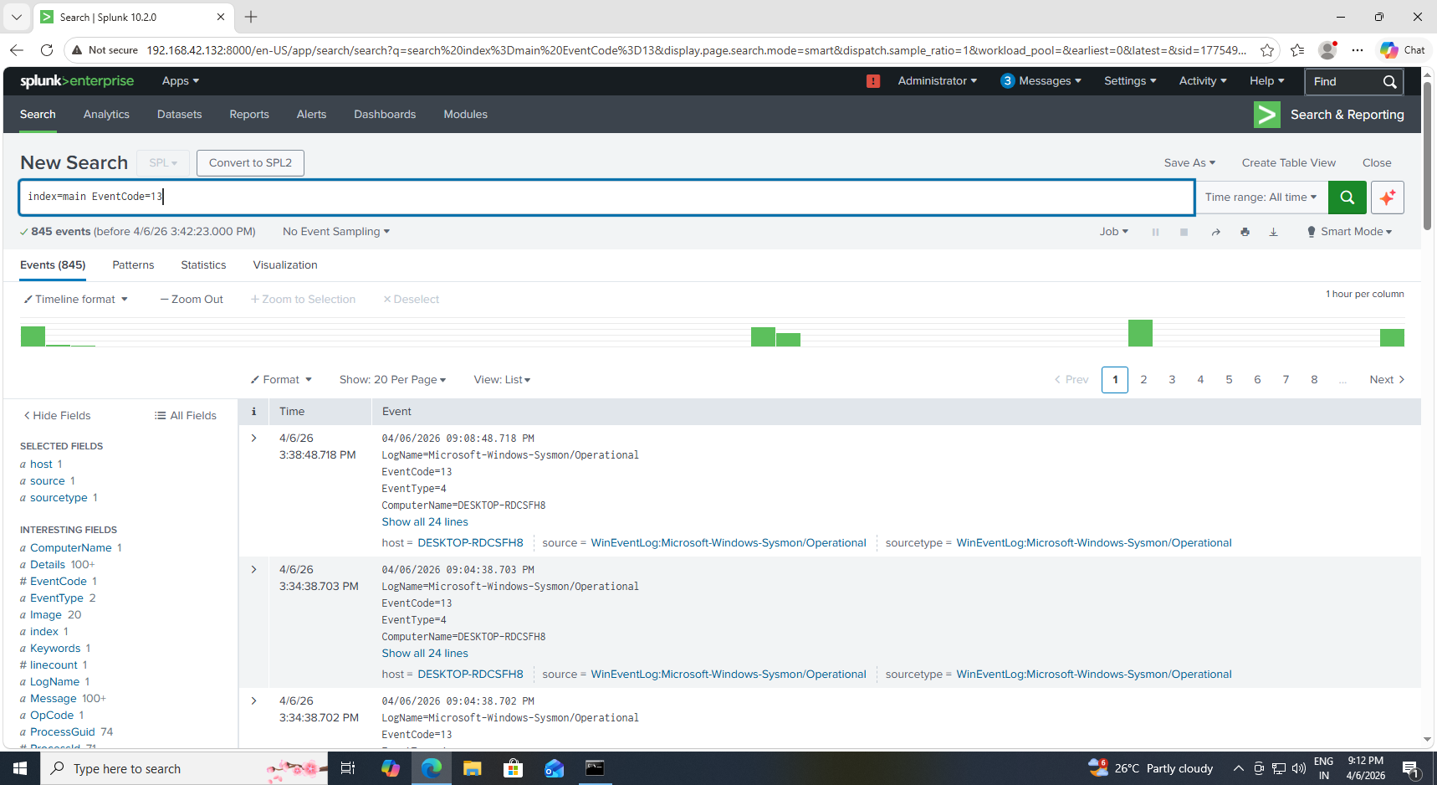
Figure 21: Dashboard Panel Showing Registry Persistence Activity

Step 7: Build Dashboard
A dashboard was created to visualize logs and monitor system activity.

Figure 22: Splunk Dashboard Showing Real-Time Threat Monitoring

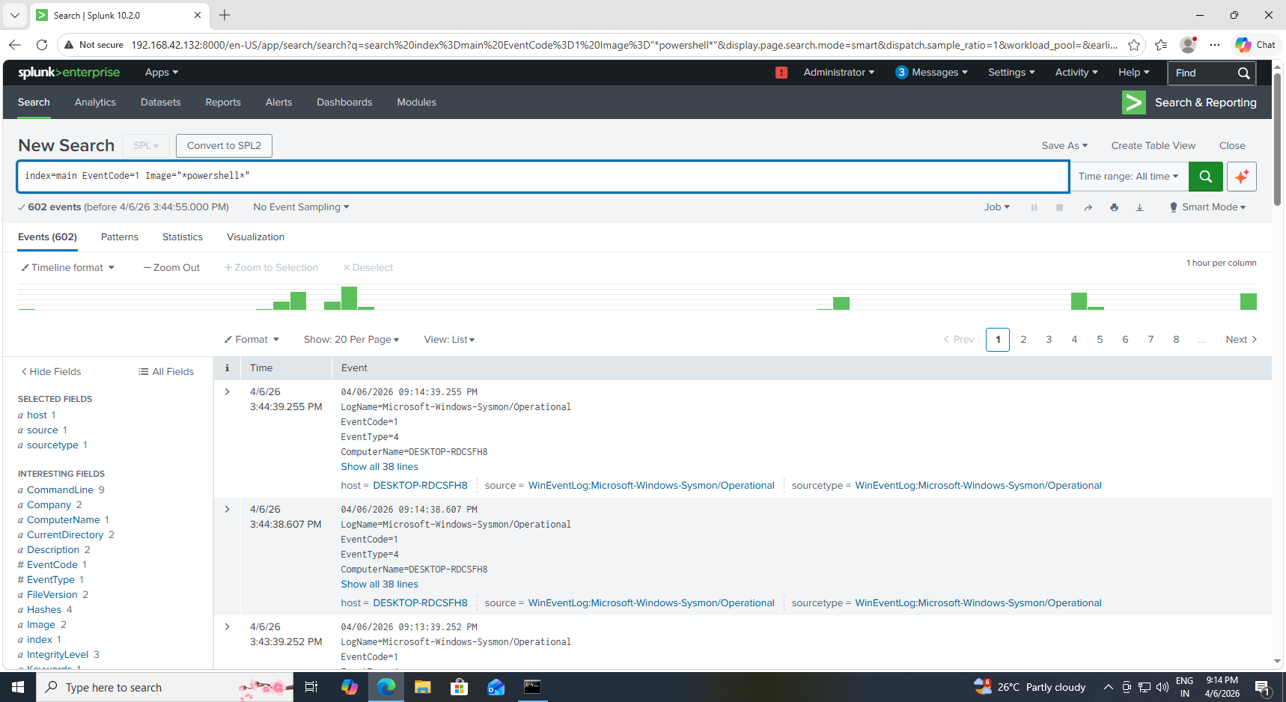
Figure 23: Dashboard Panel Displaying PowerShell Execution Activity

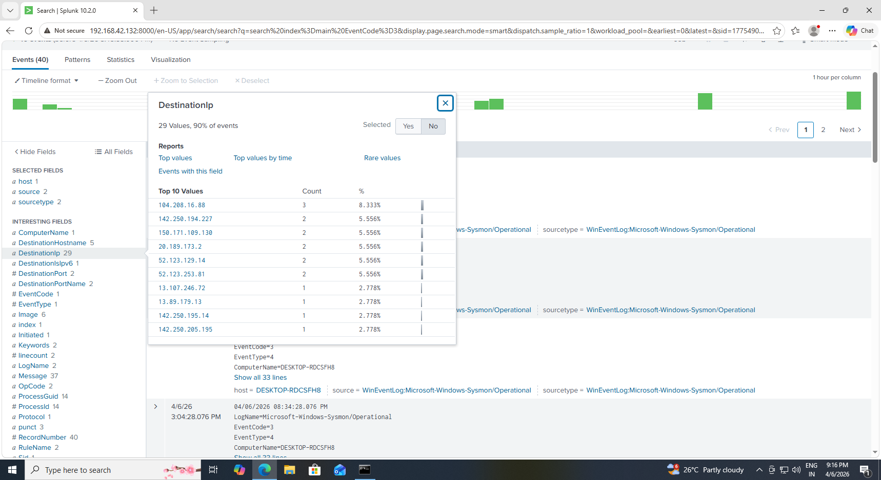
Figure 24: Dashboard Panel Showing Network Connection Activity

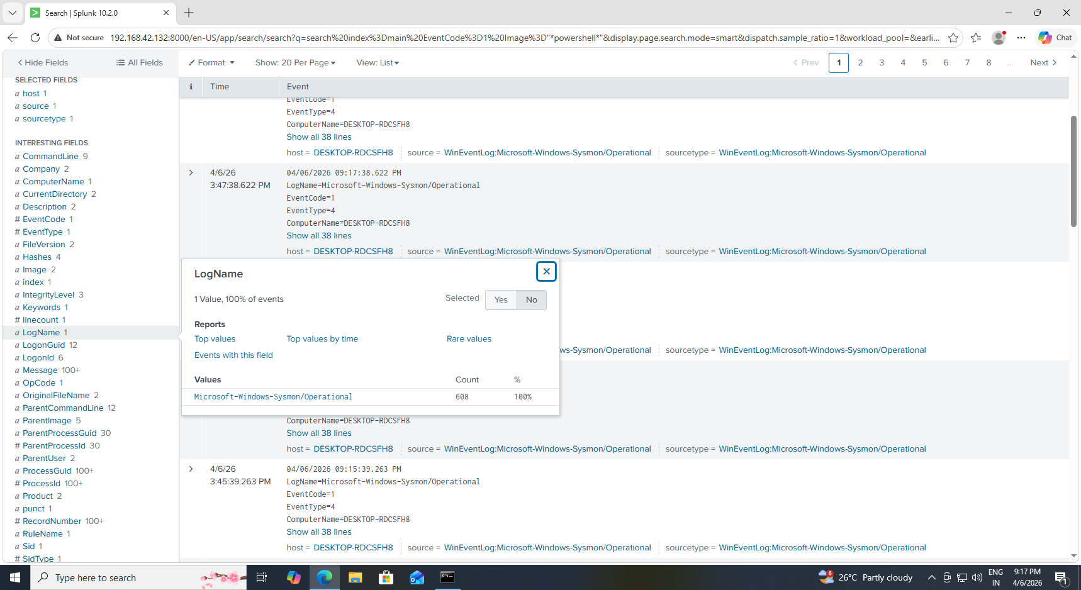
Figure 25: Dashboard Panel Displaying PowerShell Execution Activity

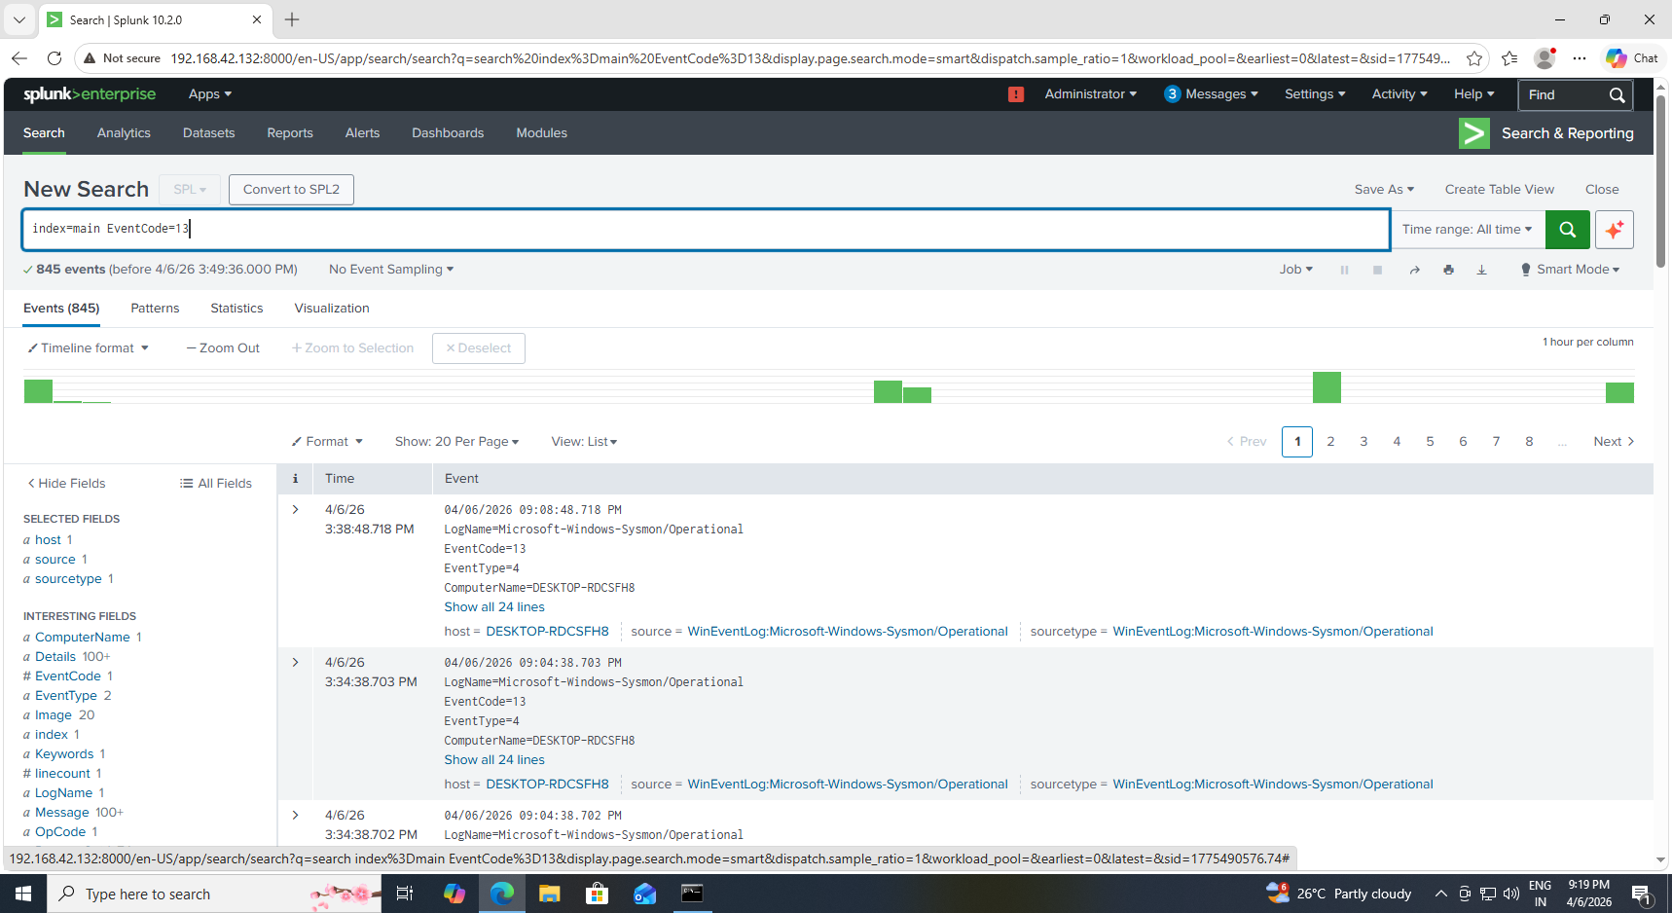
Figure 26 : Dashboard Panel Showing Registry PersistenceEvents
7. Attack Simulation
The following attack techniques were simulated:
- PowerShell Execution
- Encoded PowerShell commands
- Registry persistence using Run keys
- Network activity using ping and web requests
These actions mimic real attacker behavior.
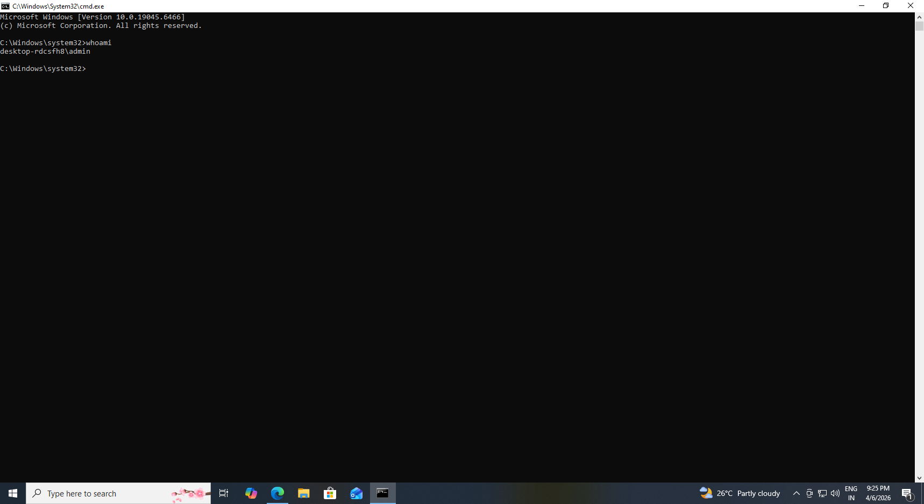
Figure 27: Normal Command Execution for Baseline Activity
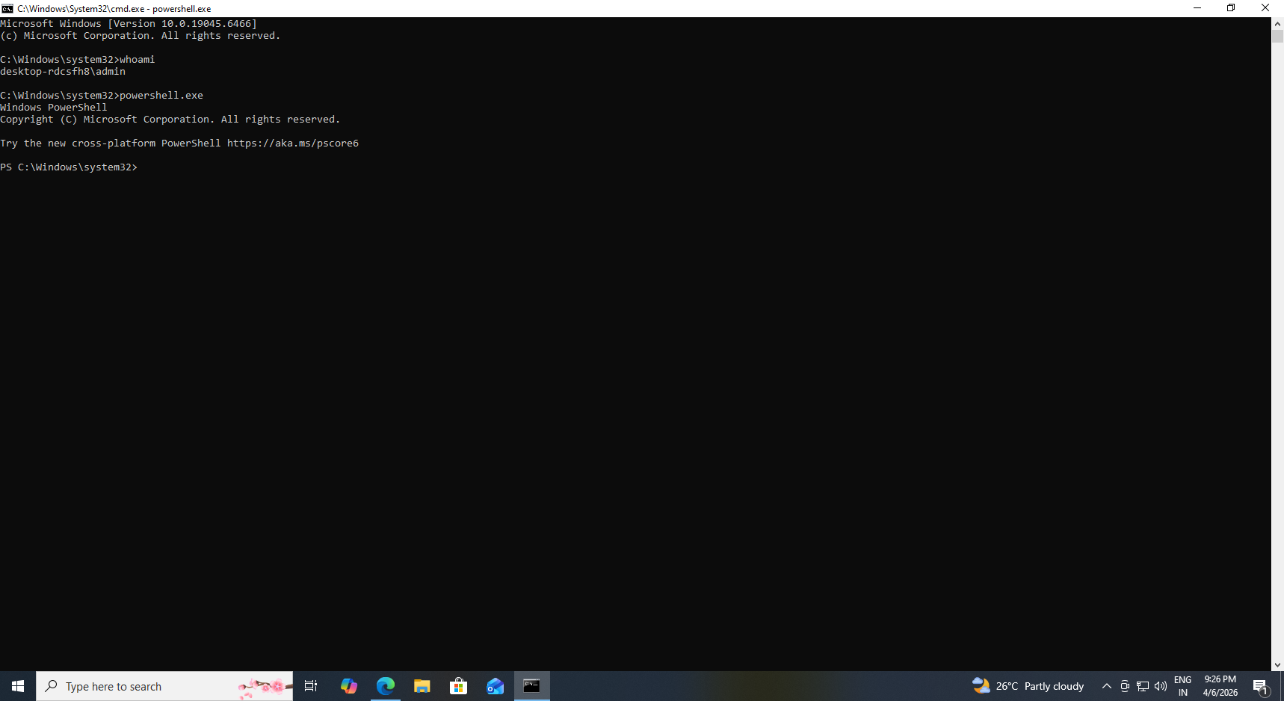
Figure 28: Execution of PowerShell Command (Simulated Attack Behavior)
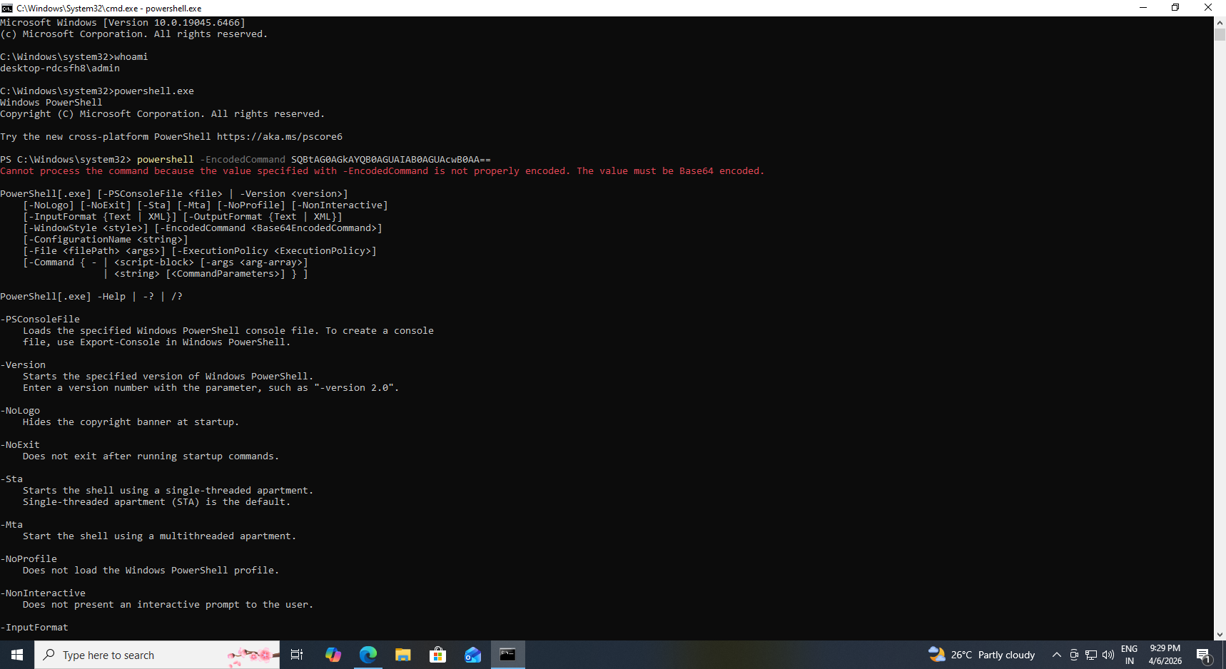
Figure 29: Execution of Encoded PowerShell Command (Obfuscation Techniques)
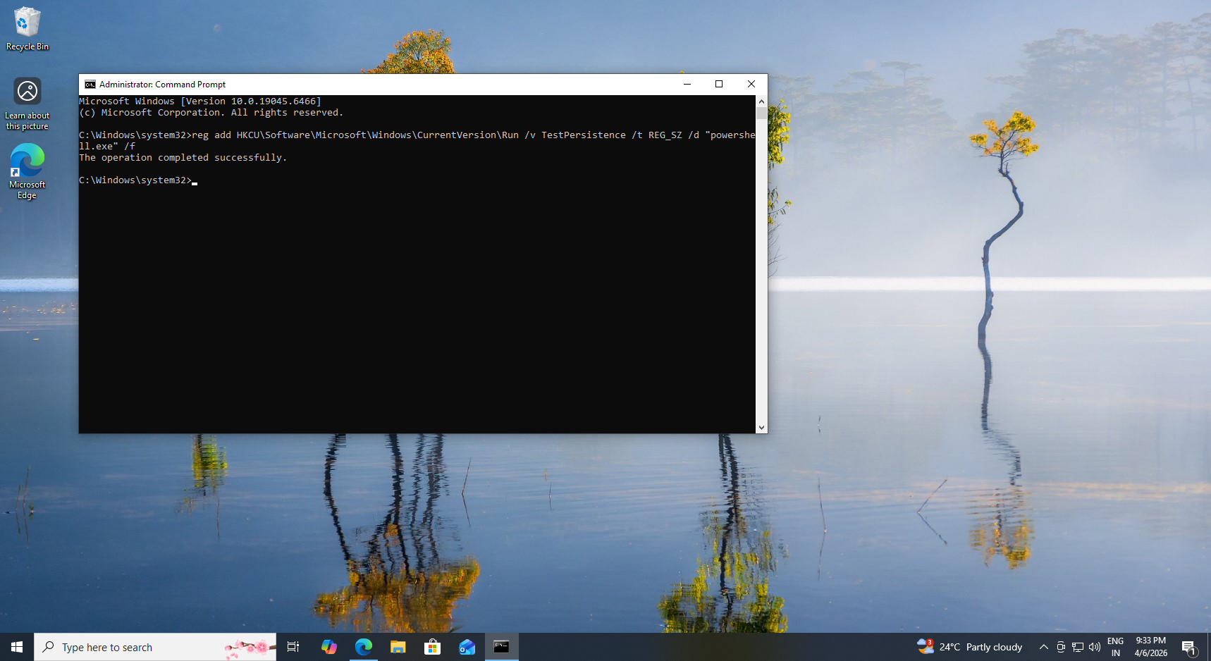
Figure 30: Registry Persistence Technique Simulation

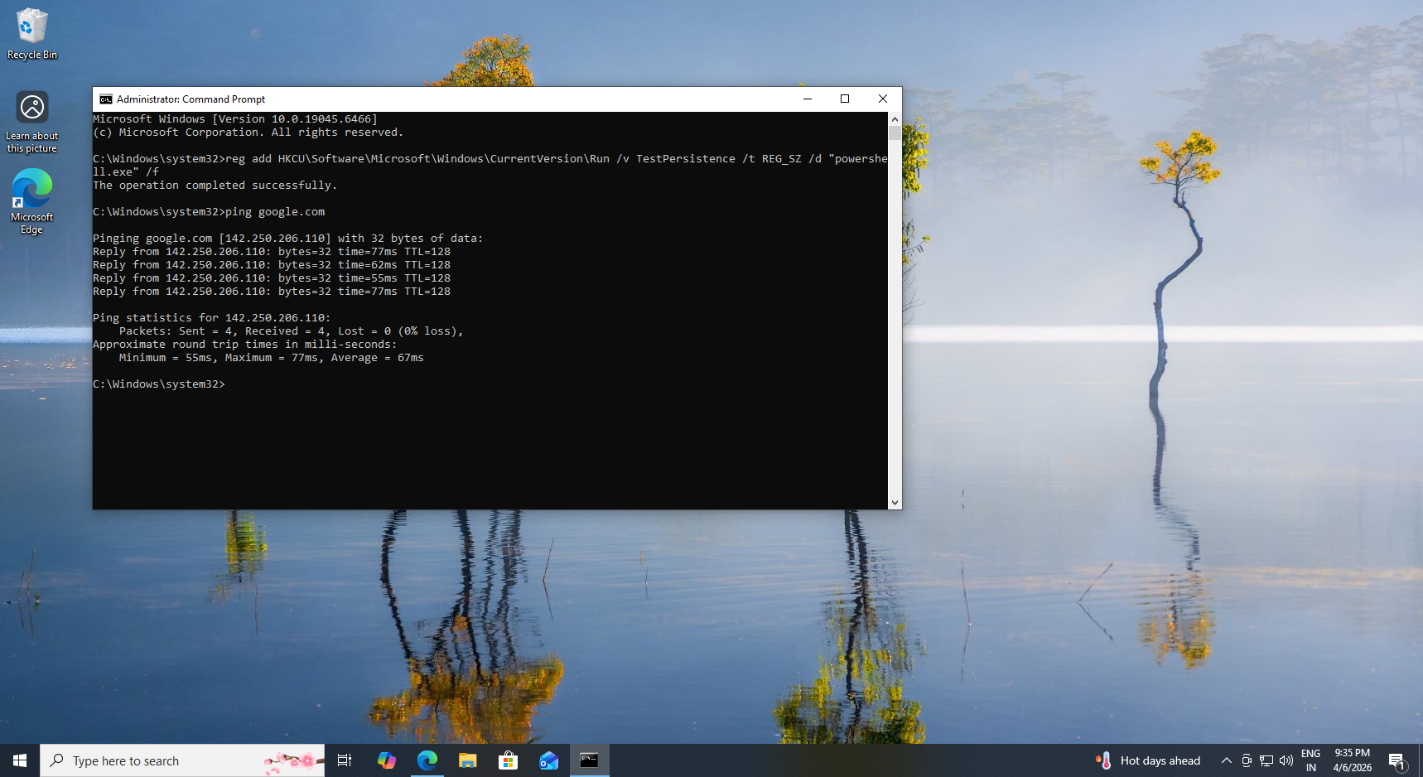
Figure 31: Network Activity Simulation
8. Detection Techniques
The following Sysmon Event IDs were used:
Event Code Description
1 Process Creation
3 Network Connection
13 Registry Modification

Example Detection Queries:
- Detect PowerShell:
index=main EventCode=1 Image="*powershell*"

- Detect Encoded Commands:
index=main EventCode=1 CommandLine="*EncodedCommand*"

- Detect Persistence:
index=main EventCode=13 TargetObject="*Run*"

- Detect Network Activity:
index=main EventCode=3

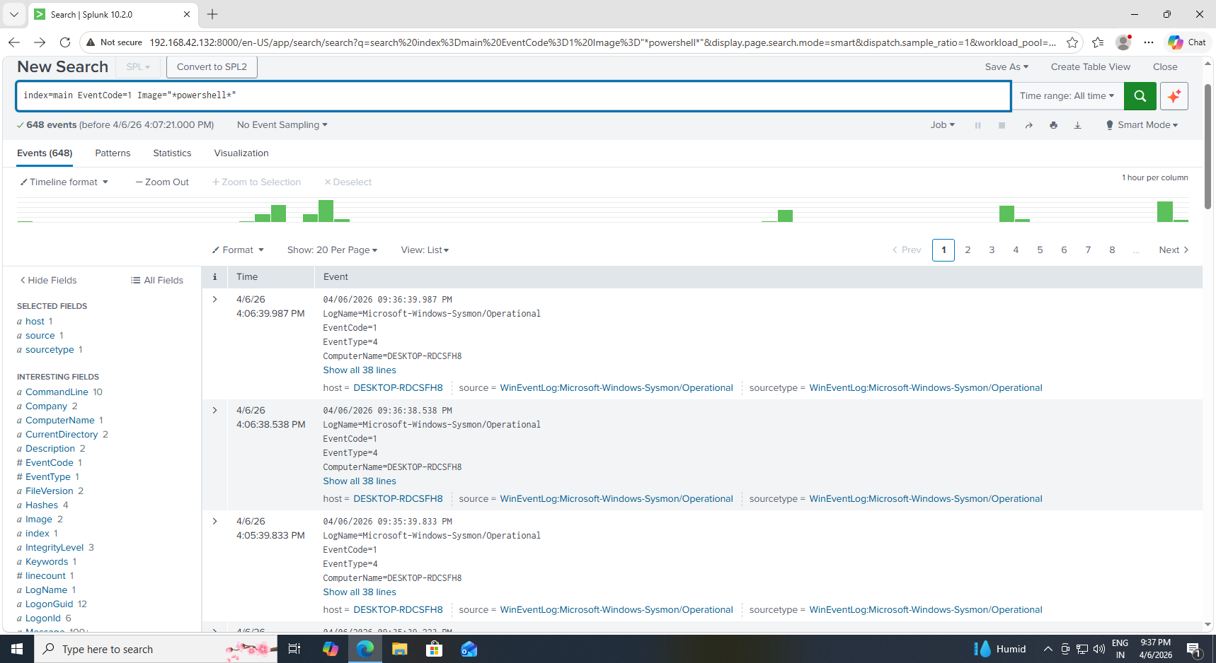
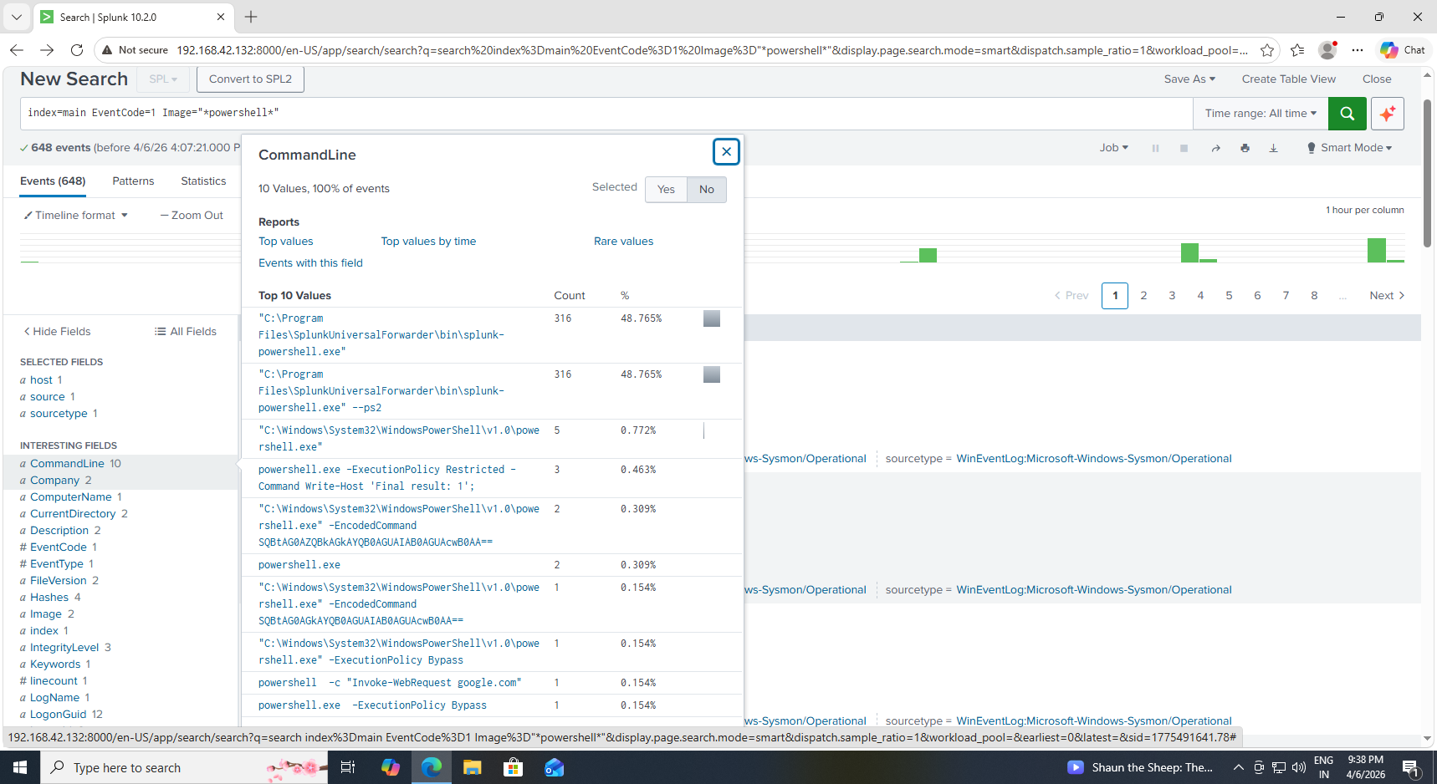
Figure 32: Detection of PowerShell Execution using EventCode 1
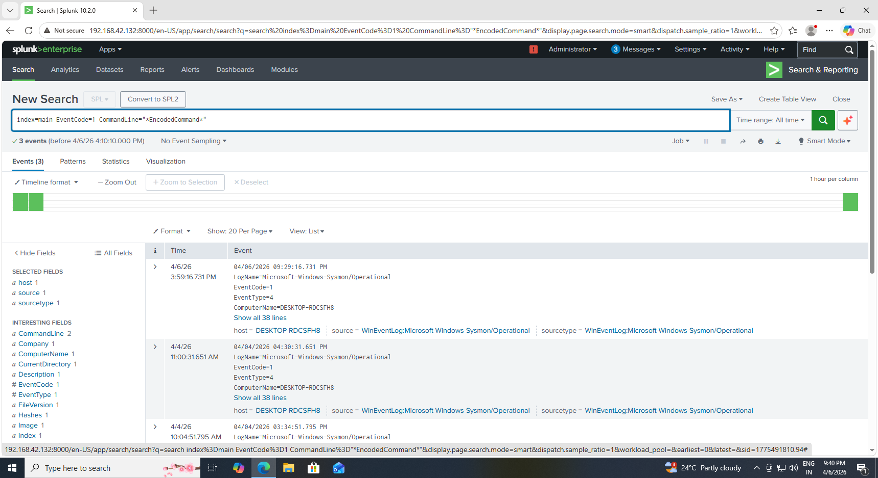
Figure 33: Detection of Encoded PowerShell Command

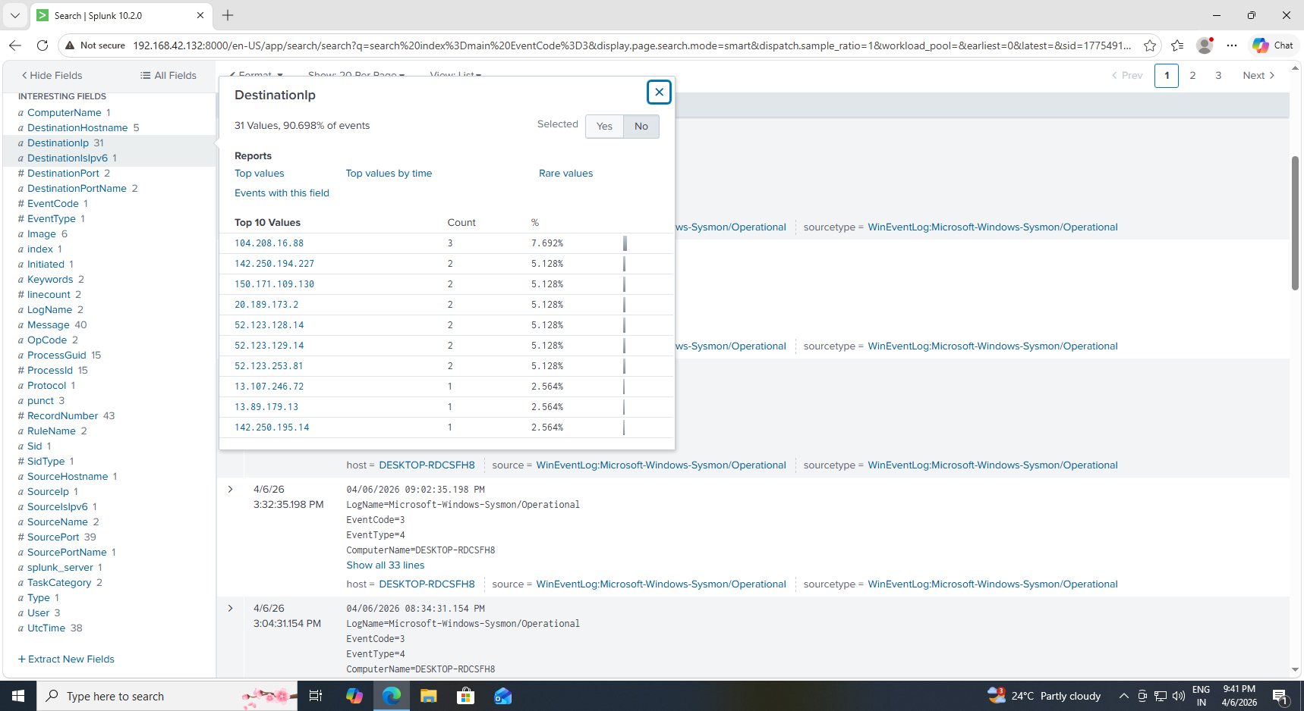
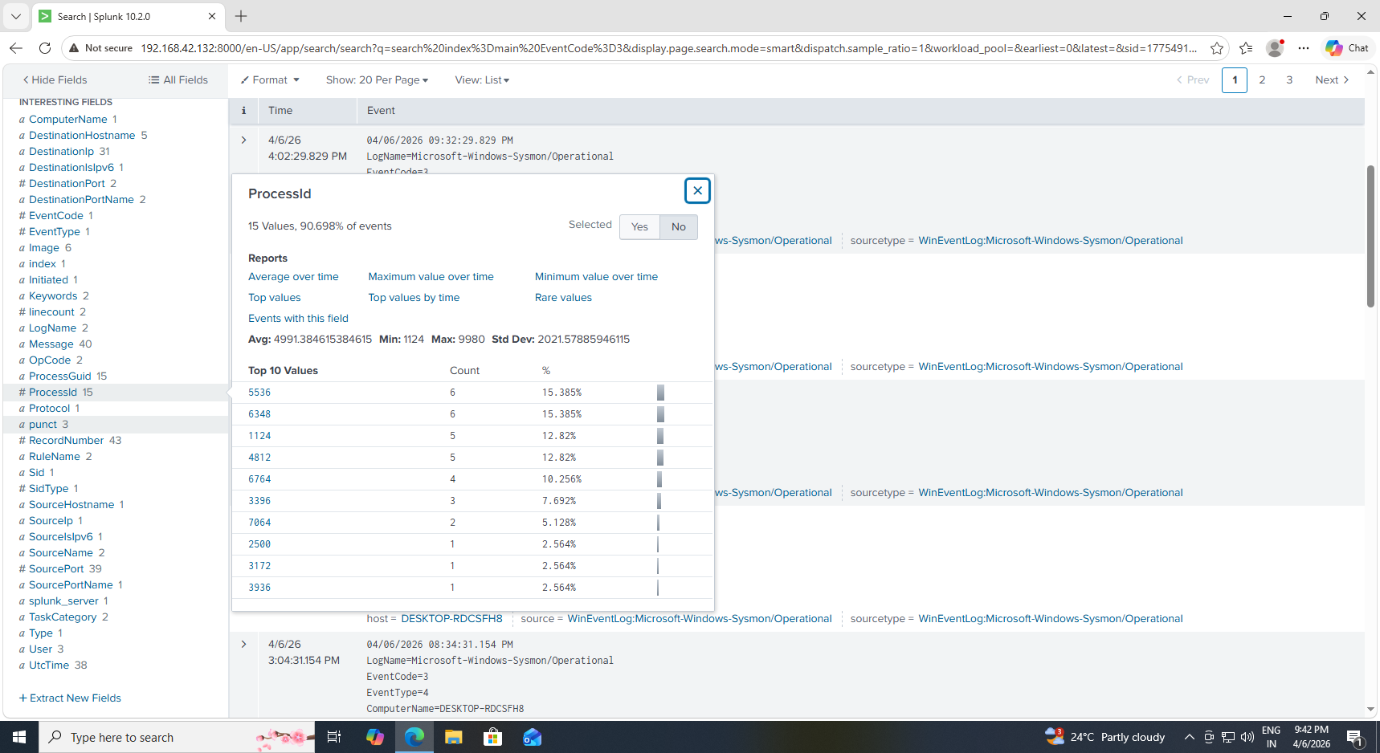
Figure 34: Detection of Network Connections using EventCode 3

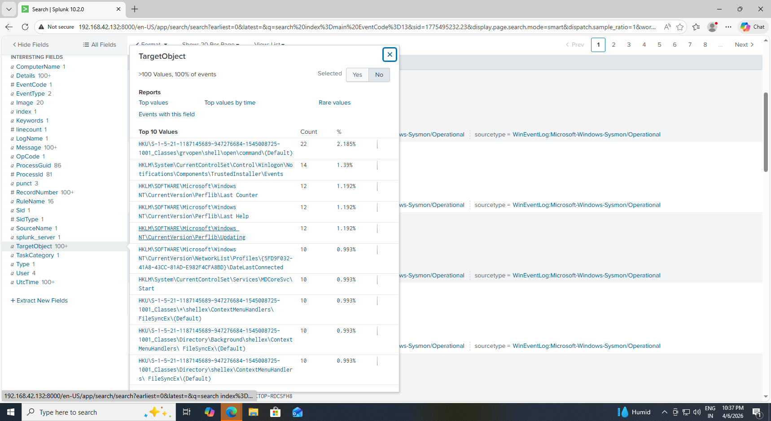
Figure 35: Detection of Registry Persistence Activity

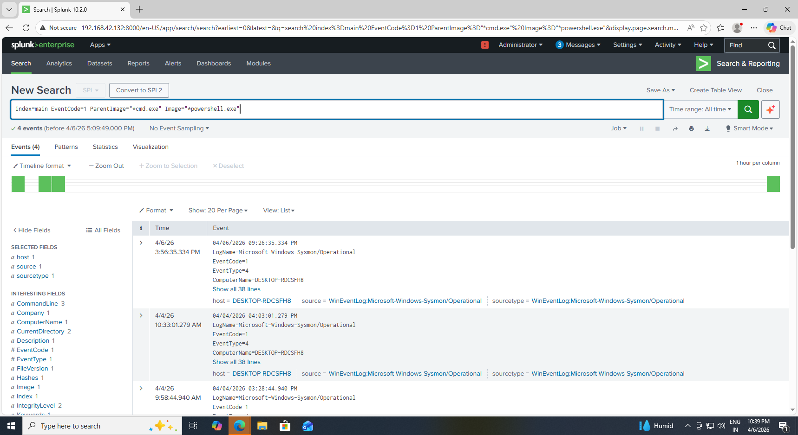
Figure 36: Detection of Suspicious Parent-Child Process Relationship

9. Dashboard
A dashboard was created in Splunk with the following panels:

The dashboard provides centralized monitoring of system activity and helps identify suspicious behavior in real time.

- PowerShell Activity
- Encoded Command Detection
- Command Prompt Activity
- Network Connections
- Registry Persistence
- Process Relationships
- Activity Timeline
The dashboard provides real-time monitoring of system behavior.

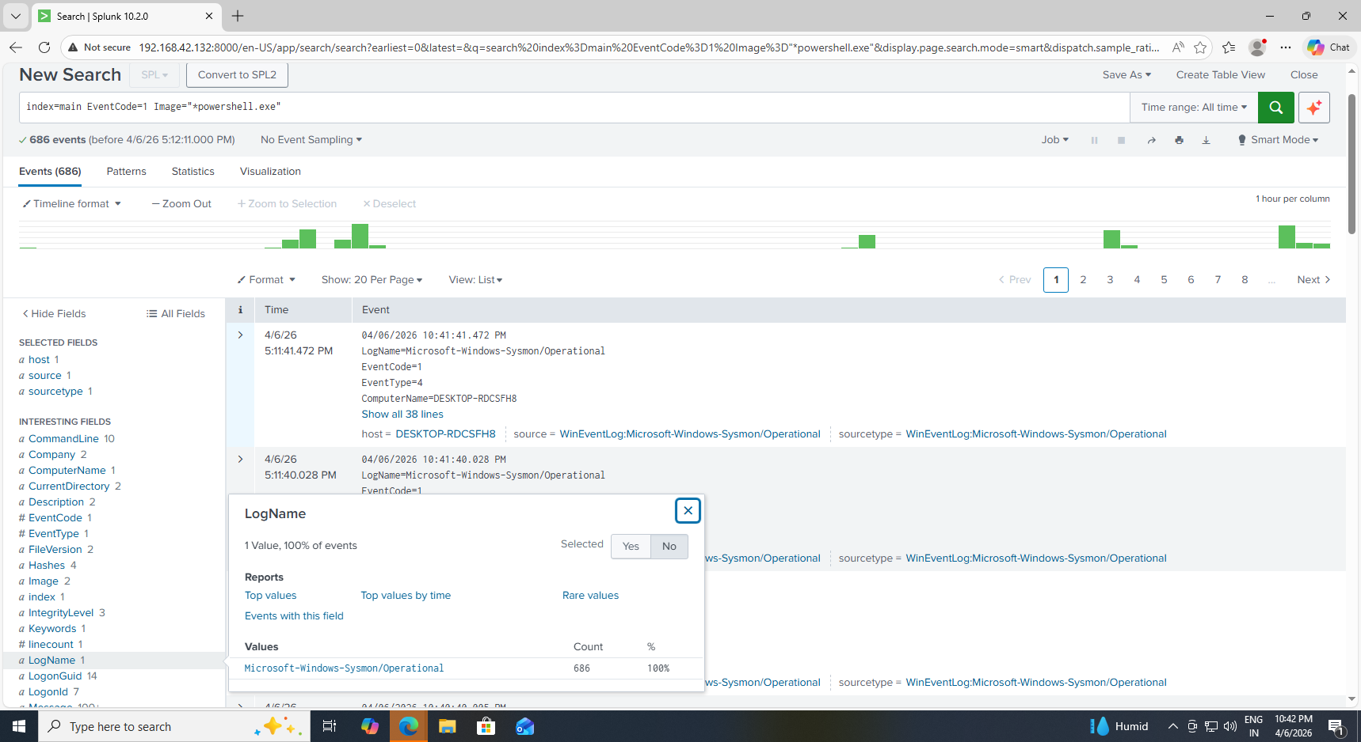

Figure 38: Dashboard Panel Showing PowerShell Execution Activity

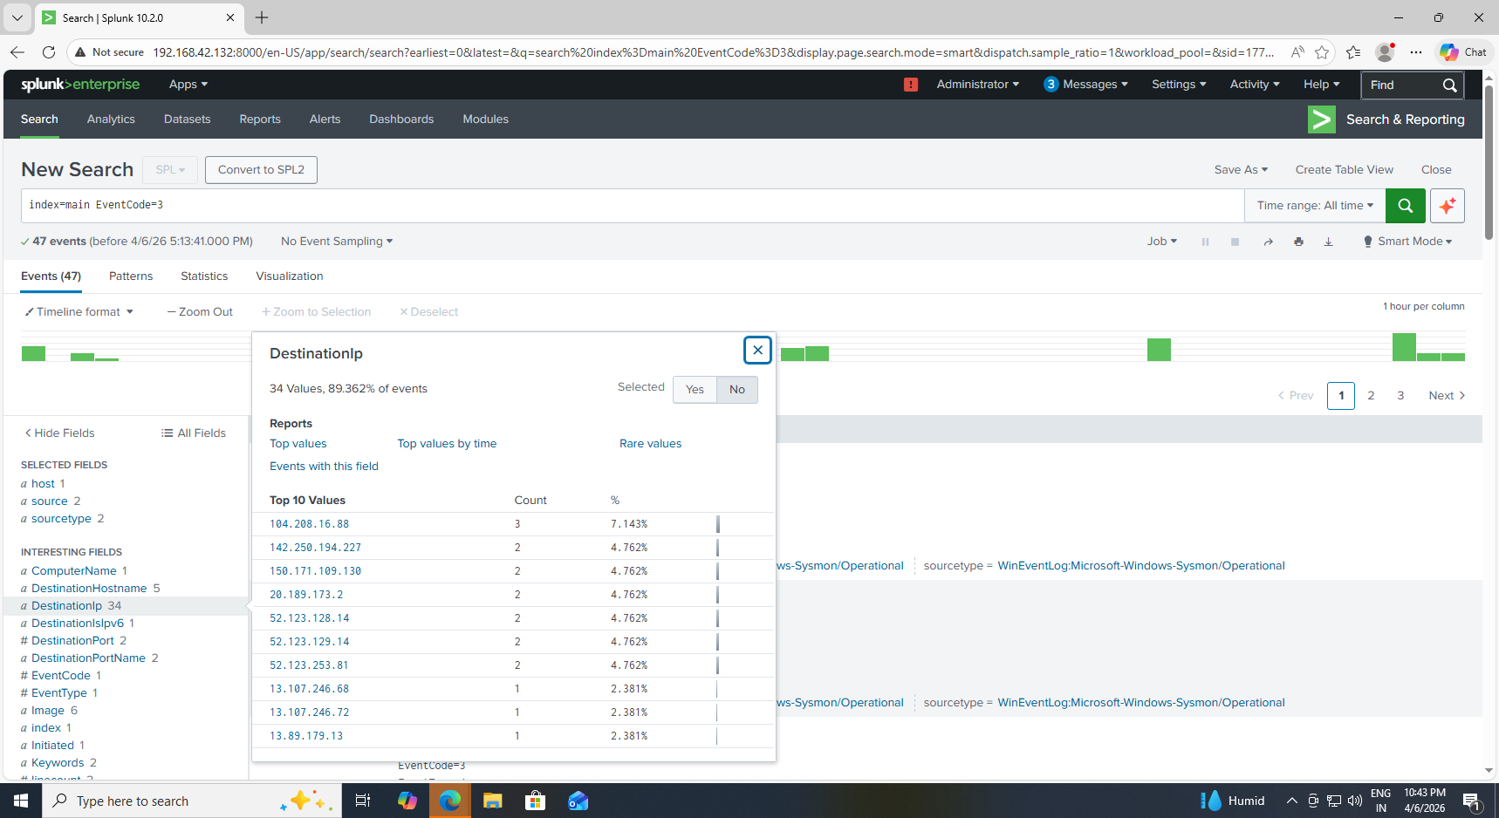
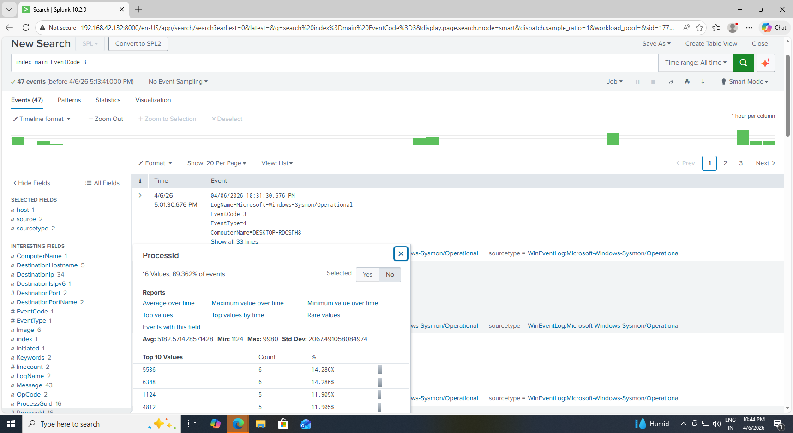
Figure 39: Dashboard Panel Showing Network Activity

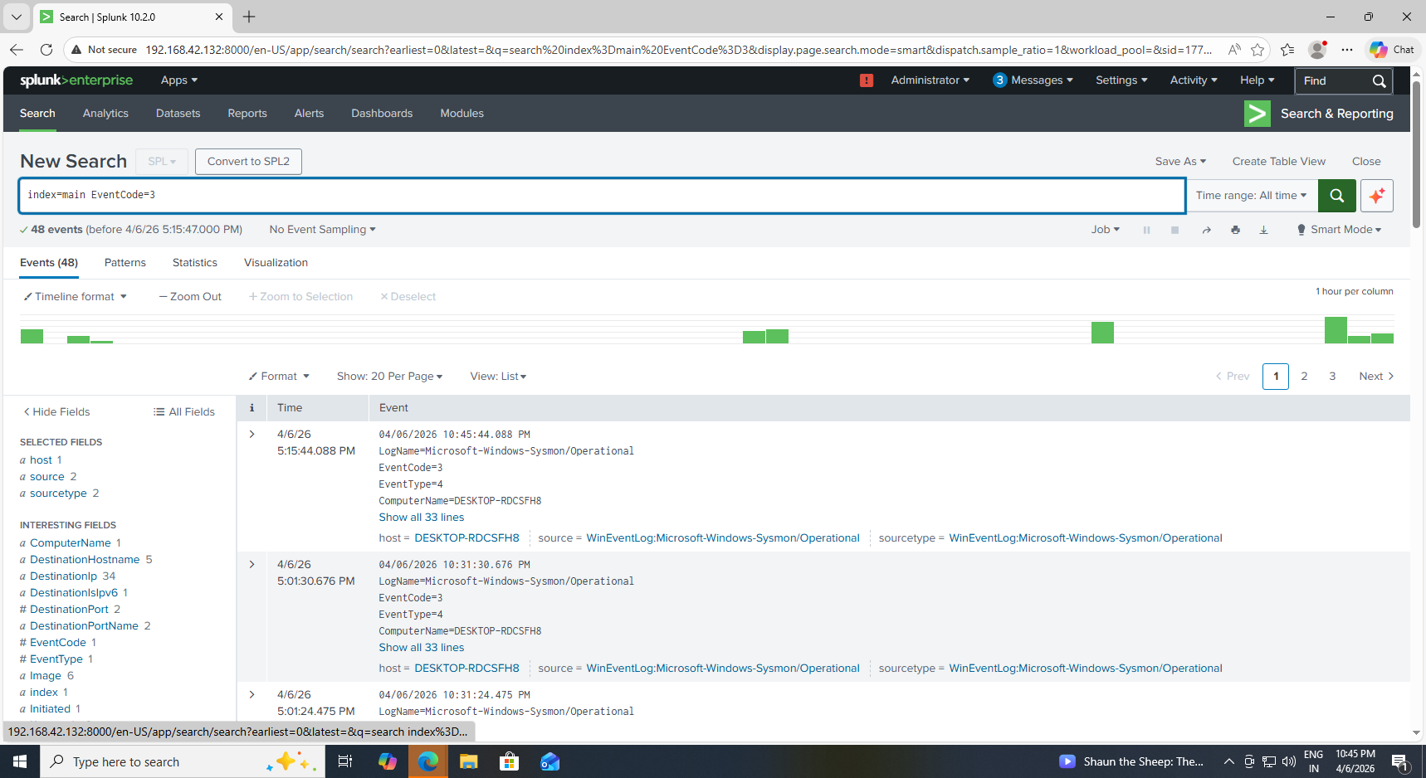
Figure 40 : Dashboard Panel Showing Registry Persistence Activity

10.Results
- The system was successfully implemented and tested using multiple attack scenarios. Logs were collected from the Windows machine and forwarded to the Splunk server in real time.
- Simulated attacks such as PowerShell execution, encoded commands, registry persistence, and network communication were successfully detected using Splunk queries.
- Alerts were triggered automatically when suspicious activity occurred, demonstrating the effectiveness of the detection system.
- The dashboard provided a clear and centralized visualization of all activities, enabling efficient monitoring and analysis.

11. Challenges Faced
- Difficulty in connecting forwarder to Splunk
- Sysmon configuration issues
- No logs appearing initially in Splunk
- Network logs not generated properly

Solutions:
- Corrected configuration files
- Restarted services
- Verified connectivity
- Applied proper Sysmon configuration

12. Conclusion
This project provided practical experience in building a SIEM system and detecting cyber attacks. It helped in understanding how attackers operate and how their behavior can be detected using logs. The use of Splunk and Sysmon proved effective in monitoring and analyzing system activity. This project enhances skills required for real-world cybersecurity roles.

13.Future Scope
- Integration with cloud-based SIEM
- Use of machine learning for threat detection
- Automated response systems
- Advanced attack simulation

14.References
- Splunk Official Documentation
- Sysmon GitHub Repository
- Microsoft Documentation
- Online Cybersecurity Tutorials

